

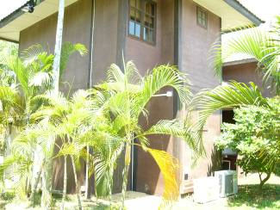
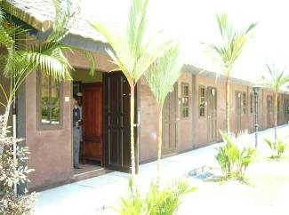
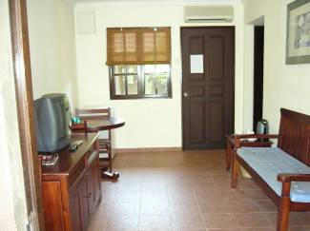
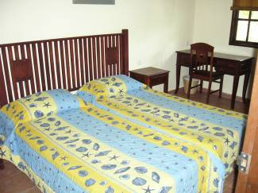


Family Day 2005
Island Escapade @ MCC Pulau Ubin
A date not to be missed 3rd - 4th Sep
Games & Activities
Treasure Hunt
Cycling
Kayaking
Beach Soccer
Jungle Run
Fishing
Telematch
Beach Volleyball
BBQ Night
Traditional Island
B'fast
Babi Hutan Hunt
(volunteers please)
Prizes
25
years
Silver going for Gold
Goodies for Kids
campfire
Hares
Muruku Mama
Kaki Tengah
Belakang Kira
Run Some More
Shortie Roo

Woodlands Transport
Taurus Multitrade Pte Ltd
Carlsberg S’pore Pte Ltd
StarHub
Different Taste Restaurant
Topman Trading
BML Vehicle Repairer Pte Ltd

Chuan Campbell
Yeo Cheow Chye
Jagdeep Singh
Tay Tong Yiaw
Harjeet Singh
Tan Sim Lay
James III Eller
Raymond Ho
Brian Teo
Philip Ying
Henry Choo
Eddie Yen
Maureen
Ghim Moh Kaki’s :
Yeoh Ah Bah
Beach Rd Fish Head Bee Hoon & Porridge
Li Ji Coffee Shop
Yeo Beng Seng
Hoe Kee Chicken Rice
Thoi Lai Chua Provision Shop
Thye Hong Fish Ball Mee



SHHH Family Day 2005
FAMILY DAY 2005
3RD September 2005

Children, Ladies and Gentlemen

The Organising Committee of the 2005 Seletar Hash House Harriers Family Day takes great pleasure to welcome you to this great island of our nation.

We must say that we never expected to be the organizers for this event until the GM of the club approached us and said that you guys are on the Family Day. We were not given the option to reject GM’s orders. He simply said this is an order from the Chief and you just comply with it.

What choice was there for us? The only option was to file an application to appeal against the orders. Having considered the merits of an appeal and taking into consideration that the GM will again hear the appeal, we decided to drop the option of an appeal. In fact, we were very concerned that the GM will enhance his orders and that will land us with more orders to comply to. We therefore decided to comply with the GM’s order.

Seletar’s gala event for this year was the 25th Anniversary Celebration on 25th June 2005. We therefore could not do much until that event was over. Our planning proper started early July. We had about 2 months to put together all the jigsaw puzzles in order to get the full picture.

One of GM’s order was that the event must be an outstation affair. The Organising Committee consulted their legal consultant and it was agreed that Pulau Ubin falls within the ambit of GM’s requirement. We were very fortunate to have found this resort to accommodate all of us for this event. Taking into account that this weekend falls within the school holiday period, we must say that lady luck was on our side.

From the time the place was selected, active work started on producing the flyers, registration forms and getting members to sign up. The food for the event was carefully considered and after several meetings, we decided to have a barbeque cum campfire. We belief the kids and the rest will love it. We also took into account that that not many kids would have attended a campfire.

The rest is history. What you see today has been the effort put in by the Organising Committee. At this juncture, we must thank the following members who came forward when asked to help. If we have left any one of you, we apologise for the oversight.

We trust you will have a memorable weekend. Just sit back and relax into the world of fantasy.

Harjeet Singh
Eddie Yen
Richard Holland

Tay Tong Yiaw
Eller James III

Baljit Singh
Raymond Ho

DOUGH REEVES - M.LOGANATHAN - D.VIJAYAKUMARAN
SUKHDEV SINGH - LOW CHOON SENG

Programme
3-Sep-05
11.00 | Meeting time at Marina Country Club. 600 Ponggol Seventeenth Ave
11.30 | Ferry leaves from Ponggol
12.00 | Registration and check in
1.00 | Lunch
2.00 | Group Beach soccer
3.00 | Telematch/Games
5.00 | Run
5.45 | Circle
7.30 | BBQ
9.30 | Campfire, Music, Prizes and Lucky Draw
11.30 | Merry Time
4-Sep-05
9.00 | Breakfast - free & easy
10.30 | Free and Easy
12.00 | Lunch
1.30 | Free and Easy
2.30 | Pack Up
3.00 | Ferry to Mainland

