
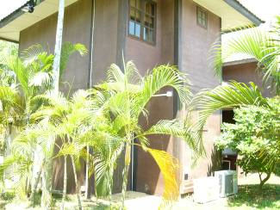
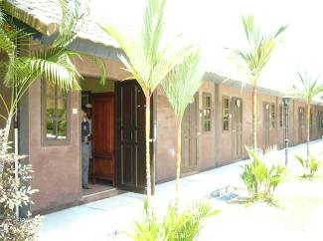
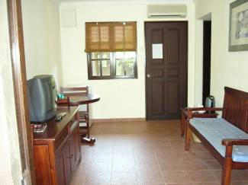
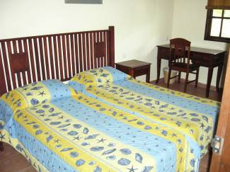
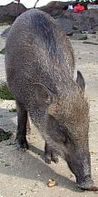

Family Day 2005
Island Escapade @ MCC Pulau Ubin
A date not to be missed 3rd - 4th Sep
Games & Activities
Treasure Hunt
Cycling
Kayaking
Beach Soccer
Jungle Run
Fishing
Telematch
Beach Volleyball
BBQ Night
Traditional Island
B'fast
Babi Hutan Hunt
(volunteers please)
Prizes
25
years
Silver going for Gold
Goodies for Kids
campfire

